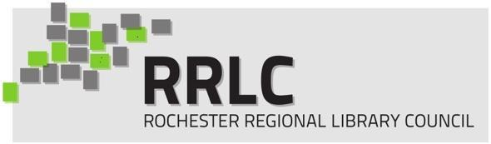

**2025 RRLC Capacity Building Grant Application**

Application Deadline: December 9, 2024 by 11:59pm  
Email applications to [rrlc@rrlc.org](mailto:rrlc@rrlc.org)

**Library/Organization: ____________________________________**

**Director Name: ______________________ Email/Phone: _______________________**

**Project Contact Person: ____________________ Email/Phone: _______________________**  
 (if not Library Director)

**1) Provide a Detailed Description of the project, including project goals and evaluation methods.**

**2)** **How will the project help your organization fulfill its mission? How will the project impact the larger RRLC community?**  (Please include any relevant data, research, or anecdotal evidence to support the need for this project).

**4) Describe your project timeframe, including target dates of completion for key elements of the project activity.**  (projects must be able to be completed within one year from award date)

**5) List the project participants - this could include staff, board members, or community members.**

**6) What is the cost of the project? _______________ What grant amount is your library applying for? ______________ What amount is your organization able to contribute toward funding your project? ____________ Please list any in-kind funding that your organization is able to contribute toward the cost of the project; such as voluntary labor, donated supplies, donated services, etc.**  Because RRLC funding for this program is limited, projects with partial funding will be given priority.

**7) Describe your plans for sharing the project results and impact with the RRLC community.** Examples could include: written report shared with the listserv; written article for RRLC Newsletter; presentation at an RRLC event; etc.

**8) Has your organization received an RRLC Capacity Building grant in the past? If so, when, and what was your project?**  (preference will be given to organizations that have not previously been awarded a grant in the last 3 years)

**_____ (initial here) I have attached detailed documentation of any Vendors of Choice** (including name of the business, contact information, and a detailed quote for services).

***Grant Guidelines & Requirements:***

1. You must be an RRLC Member in Good Standing (current membership with no outstanding financial obligations)
2. You must demonstrate a compelling need for the project.
3. You must show a clear indication of your capacity to complete the project.
4. You must provide detailed documentation of any Vendors of Choice (including name of the business, contact information, and a current detailed vendor quote for services).
5. You must commit to completing your project within one year of the award. If any extenuating circumstances cause a delay in which you will be unable to complete on time, you must update RRLC with your status and agree upon a new completion date.
6. You must contact RRLC if a change in staff is required to complete your project (ie. applicant is no longer at your organization) and update RRLC with new project contact details.
7. You must submit both a mid-year and final report to RRLC by the required dates using forms provided by RRLC.

***Grant Timeline:***

October 21, 2024: Application Period is Open  
November 15, 2024: Consultations must be scheduled if you are planning on using Causewave Community Partners as your vendor of choice.  
December 9, 2024: Application with required documentation is due  
January 16, 2025: Board of Trustees makes final award selections  
January 20, 2025: Grant awardees notified this week  
January 31, 2025: Grant acceptance letters due; award payments sent  
July 31, 2025: Mid-year progress reports due

January, 2026: Project completion & Final Reports Due

***I certify that I have read, understand, and am able to comply with each of the Grant Requirements and Grant Timeline.***

________________________________________ _______________

Signature of Director (if applicable) Date

________________________________________ _______________

Signature of Project Contact (if applicable) Date

Email your completed application in Word or PDF format and any supporting documentation to: [rrlc@rrlc.org](mailto:rrlc@rrlc.org) with the subject line **“*Capacity Building Grant Application”***